13.39: Using the same procedure used to obtain Eq. (13.29), the potential may be
expressed as
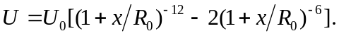
Note that at 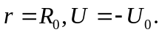 Using the appropriate forms of the binomial theorem for
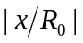 << 1,
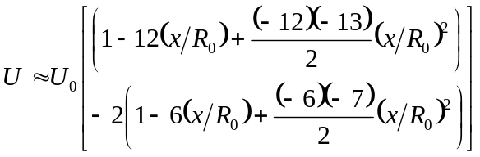
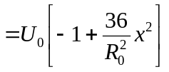
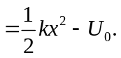
where 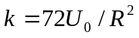 has been used. Note that terms in 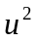 from Eq. (13.28) must be kept ; the fact that the first-order terms vanish is another indication that 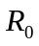 is an extreme (in this case a minimum) of U.

